Wines of the World Texas Scramble

Friday morning saw a fresh, but dry morning as players from all 16 teams gathered in good time to sign in and collect their customised scorecards for the 9:30 shotgun start of our annual Wines of the World Texas Scramble.
The weather stayed kind and the good scoring which became apparent at the end of the round was a clear testament to how well the course has held up to the recent wet weather, with several players specifically mentioning the excellent condition of the greens.
As players returned, they found the clubhouse decked in bunting and Portuguese flags, with bottles of the Portuguese red and white wines which Russ had sourced sitting on every table. A number of non-playing guests joined us and Pete and his staff excelled themselves in producing an excellent Portuguese themed meal of Piri-piri chicken (no, me neither, but apparently it is of Portuguese origin!) and a delicious Leite Crème to follow.

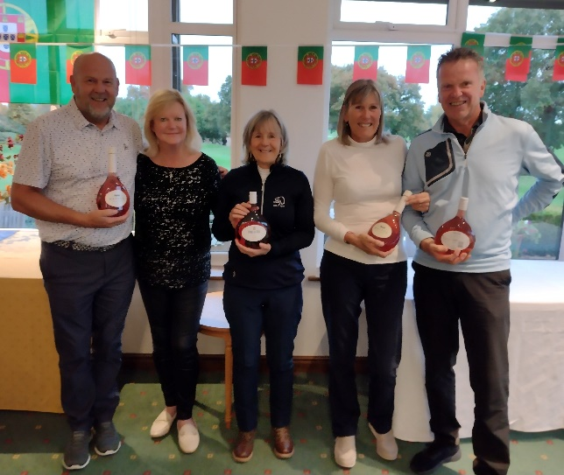
After the meal we embarked on the second competitive element of the day: Bob Parker’s legendary quiz. All players certainly learned something about Portugal, although how much of that knowledge will be useful in future is open to question! After careful scrutiny, we needed a tie-break to separate the top two teams, this was won by the team of Ged & Jane Wilkinson, Jan Woolen and Ray Gardner. Sticking with our Portuguese theme they were each presented with a bottle of Mateus Rose by our Lady Vice Captain. This was particularly magnanimous of her as it had been her team who lost the tie break!

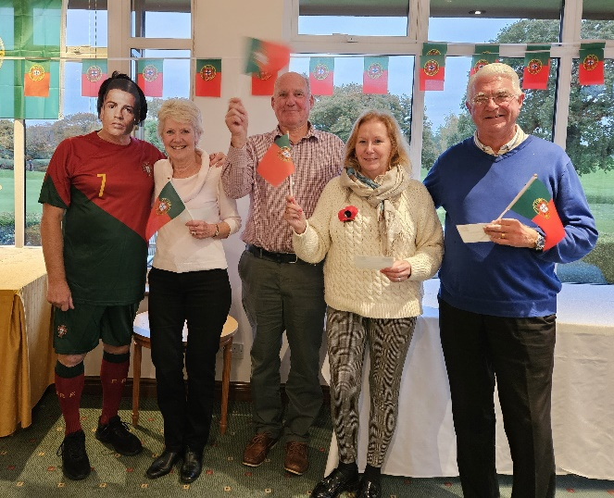
It was then time for the presentation of the prizes for the golf and the Lady Vice-Captain graciously agreed to step aside to allow our “celebrity guest” to award the prizes. Cristiano made the flamboyant entry that you might expect before presenting vouchers to Bob & Barbara Parker and Ed and Margaret Greaves who were clear winners with an excellent nett 55. Tanya Southern, Val Cunningham, Kevin Harrison and Terry Allen took 2nd prize on a CPO with a score of 57. The third placed team of Richard & Zena Nibbs, Alison Buxton and Graham Bedford received yet more bottles of Mateus Rose.
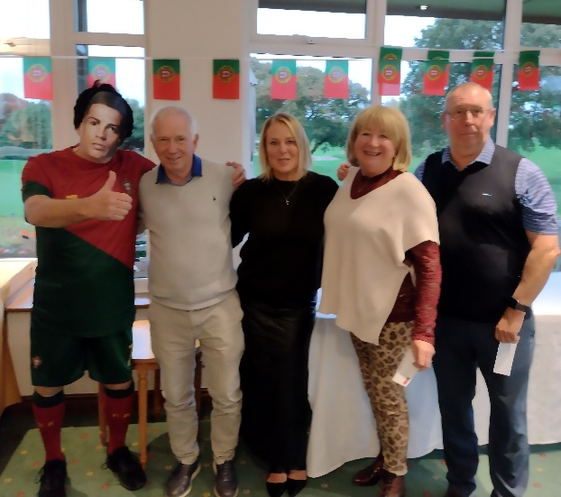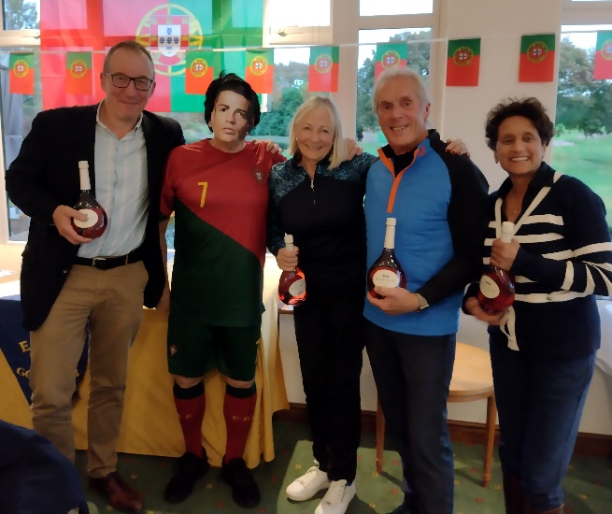

Following the presentation players lingered in the bar with Cristiano, who willingly mingled for selfies and eventually as darkness was falling, the final participants made their way home
I’d like to give my thanks to Russ, Pete and their teams, who work hard both in preparation for the day and during the event to help make ita successl. I’d also like to thank Bob Parker for running the quiz and Rob Beachan for securing the services of our guest star. Finally thanks to all who took part in the event and to those who brought guests to the meal.

David Britton

