

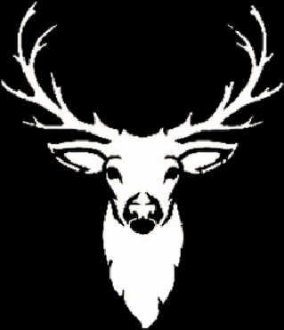
The 8th Royal Rawdon Ryder Cup
Rawdon Red Kites Buckstone Stags
THE BUCKSTONE STAGS V THE RAWDON RED KITES

Sunday 30th August
07:30 Teams to meet for coffee, tea and sausage sandwiches.
08:00 Better Ball Pairings announced.
08:30 Shotgun Start for better ball matches
10:15 Sandwich Platter
10:50 Foursome Pairings announced.
11:15 Shotgun start for foursomes
13:00 Scoring and interval for players to make use of the bar
13:30 Singles order announced
14:00 Shotgun start for singles (2 matches in each 4 ball)
16:15 BBQ
17:15 Ryder Cup Presentation.
20:00 Bar Closes

The course will be closed for all other golf until 4pm
The Maximum world handicap to compete is 36.
All matches to be played over 9 holes.
There will be a maximum of 24 players in each team with full, six day and restricted members eligible to compete.
The Entry Fee is £15 a person payable in cash on the day.

