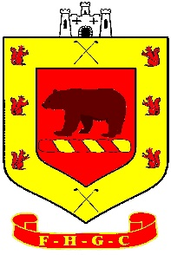

WINTER HOURS

From Sunday 27th October 2024 to Saturday 30th March 2025.

The winter bar hours are as follows if no members are present in the Clubhouse, excluding Functions and social events:
Bar & Clubhouse
Monday | 11:30am – 7:00pm (prompt close)
Tuesday | 11:30am – 7:00pm
Wednesday | 11:30am – 9:00pm
Thursday | 11:30am – 7:00pm
Friday | 11:30am – 9:00pm
Saturday | 11:00am – 8:00pm
Sunday | 11:00am – 6:00pm

Pro Shop (November 2024)
Monday | 7:30am – 4:00pm
Tuesday | 7:30am – 4:00pm
Wednesday | 7:30am – 4:00pm
Thursday | 7:30am – 4:00pm
Friday | 7:30am – 4:00pm
Saturday | 7:30am – 4:00pm
Sunday | 7:30am – 4:00pm

Catering
Monday | 10:00am - 4:00pm (Last orders at 3:15pm)
Tuesday | 10:00am - 4:00pm (Last orders at 3:15pm)
Wednesday | 10:00am - 4:00pm (Last orders at 3:15pm)
Thursday | 10:00am - 4:00pm (Last orders at 3:15pm)
Friday | 10:00am - 4:00pm (Last orders at 3:15pm)
Saturday | 10:00am - 4:00pm (Last orders at 3:15pm)
Sunday | 10:00am – 3:30pm (Last orders at 3:00pm)

If the course is closed a selection of fresh packed sandwiches will be available for members to purchase.

