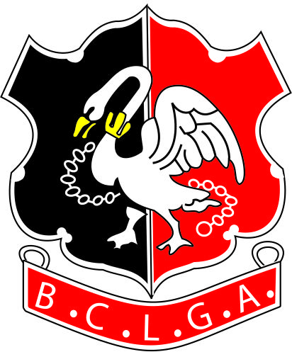 | Buckinghamshire County Ladies’ Golf Association
Adult Par 3 Competition 2020
Saturday 27th June 2020
Wycombe Heights Golf Club - Shotgun Start at 10am. Registration from 9.am
Please return this Entry Form by Friday 29th May 2020
Entry Fee: £30 per player. Entries will be on a first come first served entry basis, up to a maximum of 72 players. A reserve list will be started if oversubscribed.

The entry fee will include, tea/coffee and Danish on arrival, with a jacket potato and various fillings for lunch and prizes.
Players MUST be aged 18 + and have a CONGU Competition handicap.

PLEASE PRINT CLEARLY

Name

Club

Telephone
Email
Handicap |  |  | CDH No.

Indicate if there is anyone you wish to play with – efforts will be made to accommodate this but can not be guaranteed

Send the Entry Form to the Organiser. Payment to be made by a cheque payable to B.C.L.G.A. or use a
bank transfer as below.
Organiser: |  | Bank Details are:  Acc Name: BCLGA  Sort Code: 401712  Acc No: 51384856  Ref: Your Name Plus “Par 3”  E.g. “GStimpsonPar3”  (to identify which competition the entry relates to)
  Competition Organiser: | Gilly Stimpson
  Address | 61 St Johns Road, Tylers Green, Bucks, HP10 8HU
  Tel: | 01494 813119  07776 454459
  Email: | compssec@bclga.org.uk

Please indicate how payment has been made Cheque Yes/No Bank Transfer Yes/No

