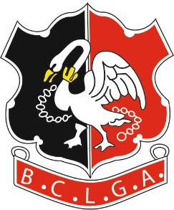 | Buckinghamshire County Ladies’ Golf Association
BUCKS CHALLENGE SHIELD 2022
ENTRY FORM
Entry fee is £30.

The competition is open to all clubs affiliated to the Buckinghamshire County Ladies Golf Association. Players must be members of the club they are representing and may only represent one club during the competition.

Club(s)

(If the team is a composite team formed between two clubs please confirm contact details of the organiser and which club will be the nominated venue for home matches)

Please give contact details for your Bucks Shield Captain. To facilitate the fixing of matches, it is necessary to circulate each club organisers' contact details to the other club organisers in the relevant Division. BCLGA will assume that this is acceptable to the club organisers by virtue of the affiliated club entering the competition.

Name
Email
Telephone

Signed |  | (Lady Captain)

Send the Entry Form to the Organiser by 31st January 2022. Payment details are below.

Organiser:  Competition Organiser: Glenise Marfell  Tel: Mobile 01895 252780 07834 392896  Email: clubcomps@bclga.org.uk | Bank Details are:  Acc Name: BCLGA  Sort Code: 401712  Acc No: 51384856  Ref: Your Club Name Plus “Bucks S” E.g. “Denham Bucks S”  (to identify which competition the entry relates to)

