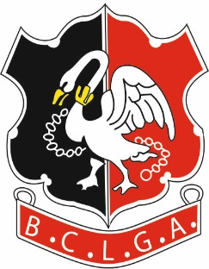 | Buckinghamshire County Ladies Golf Association
COUNTY CHAMPIONSHIPS 2022
Incorporating the Intermediate Championships
at
ELLESBOROUGH GOLF CLUB

Tuesday 3rd May 2022 - Stroke Play Rounds

Saturday 7th & Sunday 8th May 2022 – Match Play Rounds
County Championships:
Open to any Amateur FULL member of BCLGA with a WHS Handicap Index of 22.0 or lower.
Tuesday 3rd May 2022: - 36-hole stroke play qualifying rounds: Scratch & Division Handicap prizes.
Includes Intermediate Championship (for players aged between 18 & 25 on 1 January 2022) – best 36-hole gross score. Please tick shaded box below if you qualify for the Intermediate Championship.
Saturday 7th & Sunday 8th May 2022: - Leading 16 scratch scores go through to the match play stage. Please tick shaded box below if you do NOT want to go through to the Match Play rounds.
CLOSING DATE FOR ENTRIES: - Friday 8th April 2022
Entry Fee:
£30 for all entrants, including Coffee & Danish pastry or Bacon Rolls on arrival and Lunch on Tuesday 3rd May.

Caddie - Coffee & Danish pastry or Bacon Roll: £5
Caddie - Lunch: £9.50
Send the Entry Form to the Organiser. Payment to be made by a bank transfer as below.
Bank Details:
Account Name: BCLGA; Sort Code: 401712; Account No: 51384856; Ref: Your Name Plus “Champs”
E.g. “JMaherChamps” (to identify which competition the entry relates to)

Organiser: Jackie Maher
Tel: 07722 020186 Email: Compssec@bclga.org.uk

PLEASE PRINT CLEARLY
Name |  |  |  | Home Club
Tick shaded box(es) as appropriate | Intermediate |  | NO Match Play

Telephone *
Email *
Handicap Index |  |  | CDH No.
ICE Contact |  | Name |  |  | Tel
Payment |  |  | (Inc Caddie Coffee & Danish ….. x £5 and Lunch ……… x £9.50)

Please specify any dietary requirements –
* If entrant is under 16, please give telephone and email contact details for parent/carer.

