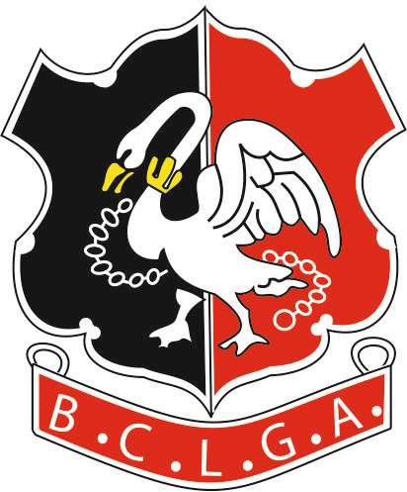 | Buckinghamshire County Ladies Golf Association  CYGNET TROPHY  ENTRY FORM

To be played between 1st April and 30th September 2022
Results to be returned to the organiser by 5th October 2022
Organiser: | Jackie Maher
Tel: | 01753 642116
 | 07722 020186
Email: | Compssec@bclga.org.uk

CLUB |  | Course/Tees
Course Rating |  | Par

Please enter points based on Playing Handicap (95% of Course handicap).

PLEASE PRINT CLEARLY
HANDICAP CATEGORY | WINNERS |  | POINTS

Division 1 – HI +5.0 to 13.9

Division 2 – HI 14.0 to 25.9

Division 3 – HI 26.0 to 54.0
 |  | TOTAL POINTS

Form to be returned to the organiser. Entry fee of £3 per entrant to be paid by bank transfer:

Number of entries
Total amount transferred

Bank Details are:
Acc Name: BCLGA
Sort Code: 401712
Acc No: 51384856
Ref: Your Club Plus “Cygnet”
e.g. “HazlemereCygnet”
Signed
Name and Position
Contact Email Address

