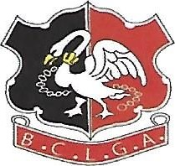
Buckinghamshire County Ladies Golf Association

BUCKS CHALLENGE SHIELD
TEAM/CLUB v TEAM/CLUB B
FIRST LEG AT CLUB A
Date:- 2020
Team/Club A results H/cap Result Points Team/Club B results H/Cap Result Points
1
2
3
4
5
6
7
RESULT LEG 1:-
SECOND LEG AT CLUB B
Date:- 2020
Team/Club A results H/Cap Result Points Team/Club B results H/Cap Result Points
1
2
3
4
5
6
7
RESULT LEG 2:-
AGGREGATE RESULT:-

