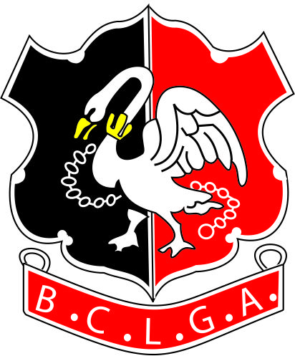 | Buckinghamshire County Ladies Golf Association
INTERCLUB FOURSOMES CUP
Thursday 17th October 2019
AT
HAREWOOD DOWNS GOLF CLUB
 | ENTRY FORM

CLUB NAME

1st Pair |  |  | Hcp &  CDH no.
1st Pair |  |  | Hcp &  CDH no.
Under 18 | Yes/No | If yes, please give contact details of a parent/guardian:  Name  Tel  Email

2nd Pair |  |  |  | Hcp&  CDH no.
2nd Pair |  |  |  | Hcp&  CDH no.
Under 18 |  | Yes/No | If yes, please give contact details of a parent/guardian:  Name  Tel  Email

Under the terms of the BCLGA Privacy Notice, any contact details for individuals will be held for the duration of the competition only and then destroyed.

In order to facilitate the organisation of this event, it is necessary to circulate each club organisers’ contact details to the other club organisers. BCLGA will assume this is acceptable to the club organisers by virtue of the affiliated club entering the competition.

Buckinghamshire County Ladies Golf Association
INTERCLUB FOURSOMES CUP
THURSDAY 17TH OCTOBER 2019
AT
HAREWOOD DOWNS GOLF CLUB

Please return entry form, catering requirements and entry fees by:
Monday 1st October 2019
(Members from Harewood Downs, as the host club do not pay a green fee)

Return the Forms to the Organiser.
Payment to be made by a cheque payable to B.C.L.G.A. or by a bank transfer as below.
Organiser:  Glenise Marfell  3 Church Road, Cowley,  Uxbridge, UB8 3NB  Tel:  01895 252780  07834 392896  Email: Iclub4somes@bclga.org.uk | Bank Details:  Acc Name: BCLGA  Sort Code: 401712  Acc No: 51384856  Ref: Club Name Plus I/C 4sms

Please indicate how payment has been made Cheque Yes/No Bank Transfer Yes/No

A rolling two course lunch, at a cost of £18.50 per head, should be ordered and paid for in advance. Caddies should be included in the numbers for lunches if required. Please can you select your choice of main and dessert courses on the attached sheet.

I enclose a cheque (payable to B.C.L.G.A.) made up as follows:

Green Fees | @ £10 per person | £40
Entry Fee | @ £10 per club | £10
Lunches | Number.....@ £18.50 per person | £ | (Please enter amount)
Total |  | £ | (Please enter amount)

Please write clearly the name and email to which all details should be sent:

Name
Email

Signed |  | (Lady Captain)

Buckinghamshire County Ladies Golf Association
INTERCLUB FOURSOMES CUP
THURSDAY 17th OCTOBER 2019
AT
HAREWOOD DOWNS GOLF CLUB
CATERING REQUIREMENTS

CLUB NAME

Please can you choose your main course from the menu below and enter the numbers required.

Main and Dessert Course

Chicken Breast, wrapped in Bacon, Sauté Potatoes, Creamed Leeks
Roasted Salmon, Bubble and Squeak Hash, Roasted Beets, Horseradish Crème Fraiche, Salsa Verde
Fruit Crumble
A Selection of Cheese and Biscuits

Tea or Coffee

If any of your players have special dietary requirements, please can you enter their details below.

