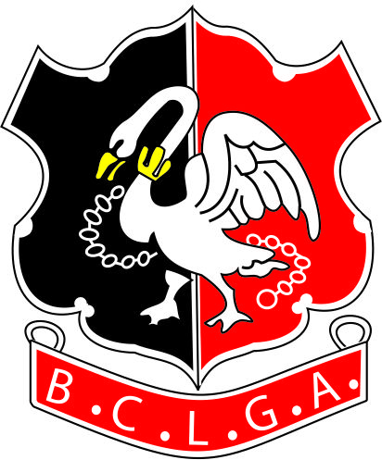 | Buckinghamshire County Ladies’ Golf Association
COUNTY PRESIDENT’S SUMMER MEETING 2021
Open to all handicaps with a WHS Handicap Index
3 BALL TEAM ALLIANCE
Teams need not be members of the same club
 | OAKLAND PARK GOLF CLUB,
 | Friday 16th July 2021
CLOSING DATE FOR ENTRIES: Friday 19th June 2021
Entry Fee: £49 per person to include:- Refreshments on arrival, Halfway Hut Drinks and Nibbles,
2 course buffet, prizes (£29.25 for Oakland Park Members)
Send the Entry Form to the Organiser. Payment by bank transfer as below.
Organiser  Jackie Maher  Phone : 01753 642116 or 07722 020186  Email – compssec@bclga.org.uk | Bank Details are:  Acc Name: BCLGA  Sort Code: 401712  Acc No: 51384856  Ref: Name Plus Sum Mtg - e.g  JMaher Sum Mtg

PLEASE PRINT CLEARLY

Player 1 Name  Age if under 18 (signature and contact no. of Parent or Guardian Required) |  |  |  | Home Club  Signature of Parent and contact No.

Player 1 Telephone
Player 1 Email
Player 1 Handicap Index |  |  | Player 1 CDH No.
Player 1 ICE* Contact |  | Name |  | Tel
Player 2 Name  Age if under 18 (signature of Parent or Guardian Required) |  |  |  | Home Club  Signature of Parent and contact No.

Player 2 Telephone

Player 2 Email
Player 2 Handicap Index |  |  | Player 2 CDH No.
Player 2 ICE* Contact |  | Name |  | Tel
Player 3 Name  Age if under 18 (signature of Parent or Guardian Required) |  |  |  | Home Club  Signature of Parent and contact No.

Player 3 Telephone

Player 3 Email
Player 3 Handicap Index |  |  | Player 3 CDH No.
Player 3 ICE* Contact |  | Name |  | Tel

PLEASE SPECIFY ANY SPECIAL DIETARY REQUIREMENTS
*ICE – In Case of Emergency

