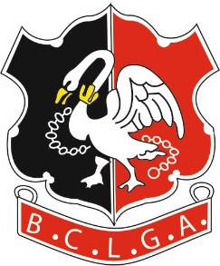 | Buckinghamshire County Ladies Golf Association
WINTER SCRATCH LEAGUE 2022-2023
Greensomes Format
CLOSING DATE FOR ENTRIES: - 31 August 2022
Before entering, please ensure that you will not have a problem fielding six players to play in each of the matches, a maximum of seven rounds played from 1 October 2022 to 31 March 2023. If your Club’s captaincy is due to change in the autumn, please enquire of your incoming Ladies’ Captain as to whom the Winter League contact will be.
If your Club has insufficient Silver Division players but is interested in forming a Composite team, please contact me for more information.
To facilitate the fixing of matches, it is necessary to circulate each club organisers' contact details to the other club organisers in the relevant Division. BCLGA will assume that this is acceptable to the club organisers by virtue of the affiliated club entering the competition.

If you are entering 2 Teams in the Competition please differentiate these teams with A or B

Club
Contact Name
Contact Email
Contact Phone Number
Alternate Contact Phone Number

If entering a Second Team
Contact Name
Contact Email
Contact Phone Number
Alternate Contact Phone Number

Entry Fee | £25 per Team
Please confirm amount paid
Form Completed on behalf of Club by
Name
Position
Email Address
Bank Details
Account Name | BCLGA
Sort Code | 401712
Account Number | 51384856
Reference | Your Club Plus “WLeague”  Eg. HazlemereWLeague

Form to be returned to:
Organiser: | Jackie Maher
Tel: | 01753 642116  07722 020186
Email: | Compssec@bclga.org.uk

