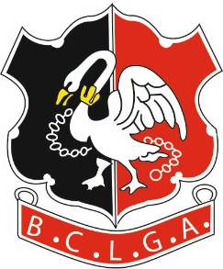 |  | Buckinghamshire County Ladies’ Golf Association
WINTER SCRATCH LEAGUE 2020/2021
Greensomes Format
CLOSING DATE FOR ENTRIES: - 31st August 2020
Form & entry fee of £25 (payable to B.C.L.G.A) to be returned to the organiser.
Organiser: | Jackie Maher  3 Nightingale Park, Farnham Common, Bucks, SL2 3SN
Tel: | 01753 642116  07722 020186
Email: | winterleague@bclga.org.uk

Before entering, please ensure that you will not have a problem fielding six players to play in each of the matches, a maximum of seven rounds played from 1 October to 31 March. If your Club’s captaincy is due to change in the autumn, please enquire of your incoming Ladies’ Captain as to whom the Winter League contact will be.
If your Club has insufficient Silver Division players but is interested in forming a Composite team, please contact me for more information.
To facilitate the fixing of matches, it is necessary to circulate each club organisers' contact details to the other club organisers in the relevant Division. BCLGA will assume that this is acceptable to the club organisers by virtue of the affiliated club entering the competition.

PLEASE PRINT CLEARLY

CLUB:-
 | Contact Email
 | Preferred Tel No. |  |  |  | Alternate No.

Entry Fee
Form & entry fee to be returned to the organiser. Please Indicate if Cheque /BACs
Bank Details are:
Acc Name: BCLGA; Sort Code: 40-17-12 Acc No: 51384856; Ref: Your Club Plus “WLeague”
E.g. “BurnhamWLeague ” (to identify which competition the entry relates to)
Alternatively send a cheque payable to B.C.L.G.A.

Signed

