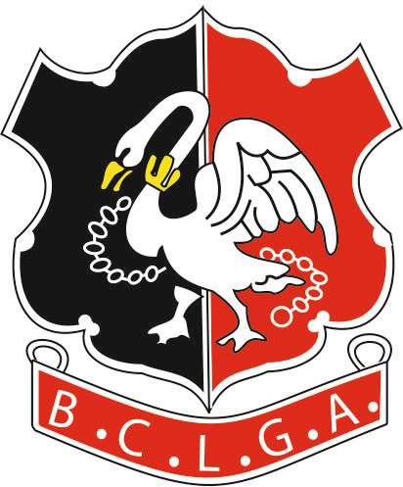 | Buckinghamshire County Ladies Golf Association  CHARITY ECLECTIC TROPHY  ENTRY FORM

Competition runs from 1st April 2022 to 15th September 2022
Results to be returned to the organiser by 1 October 2022
Organiser: | Jackie Maher
Tel: | 01753 642116, 07722 020186
Email: | Compssec@bclga.org.uk

CLUB |  |  | Course/Tees
Course Rating |  |  | Slope Rating

Please list the lowest net scores (i.e. gross scores less ½ course handicap on 16 September).

PLEASE PRINT CLEARLY
NAME | Gross Score | ½ Course Handicap | Net Score

1.

2.

3.

4.

5.

6.

7.
 |  | TOTAL
Form to be returned to the organiser. Entry fee of £3 per entrant to be paid by bank transfer:
Number of entries
Total amount transferred

Bank Details are:
Acc Name: BCLGA
Sort Code: 401712
Acc No: 51384856
Ref: Your Club Plus “CountyEcl”
e.g. “HazlemereCountyEcl ”
Signed
Name and Position
Contact Email Address

