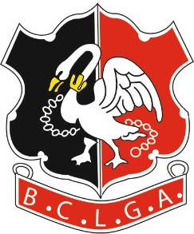 | Buckinghamshire County Ladies Golf Association
SUMMER SCRATCH LEAGUE 2022
CLOSING DATE FOR ENTRIES: - 31st January 2022
Before entering, please be sure that you will be able to field a team of three players for each of the matches. NO WALKOVERS are to be given.
To facilitate the fixing of matches, it is necessary to circulate each club organisers' contact details to the other club organisers in the relevant Division. BCLGA will assume that this is acceptable to the club organisers by virtue of the affiliated club entering the competition.

If you are entering 2 Teams in a League please differentiate these teams with A or B

Club
Division | Silver / Bronze
Contact Name
Contact Email
Contact Phone Number
Alternate Contact Phone Number

Division | Silver / Bronze
If entering a Second Team | A / B
Contact Name
Contact Email
Contact Phone Number
Alternate Contact Phone Number

Division | Silver / Bronze
If entering a Second Team | A / B
Contact Name
Contact Email
Contact Phone Number
Alternate Contact Phone Number

Division | Silver / Bronze
If entering a Second Team | A / B
Contact Name
Contact Email
Contact Phone Number
Alternate Contact Phone Number

Entry Fee | £25 per Team
Please confirm amount paid per League
Silver Scratch
Bronze Scratch
Form Completed on behalf of Club by
Name
Position
Email Address
Bank Details
Account Name | BCLGA
Sort Code | 401712
Account Number | 51384856
Reference | Your Club Plus “SLeague”  Eg. HazlemereSLeague

Form to be returned to:
League Organiser: | Jackie Maher
Tel: | 01753 642116  07722 020186
Email: | Compssec@bclga.org.uk

