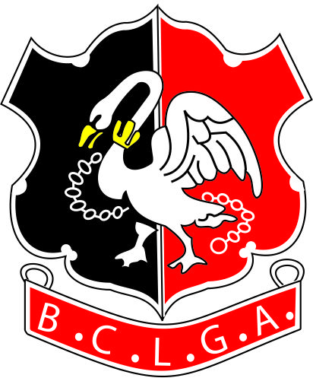 |  |  | Buckinghamshire County Ladies’ Golf Association
 |  |  | ROSE BOWL KNOCKOUT TROPHY 2022
CLOSING DATE FOR ENTRIES: - 28th February 2022
Entry Fee: £15
Handicap Limit - MINIMUM exact Handicap Index of 18.5 on closing date.
Please bear in mind holidays and availability before entering. Extensions will not be given unless both courses are closed or unavailable on the last day of the round

PLEASE PRINT CLEARLY

Name

Club

Telephone
Email
Handicap Index |  |  |  |  |  |  | CDH No.
Under 18 | Yes/No |  |  | If yes, please give contact details of a parent/guardian:  Name  Tel  Email
N.B. |  | If your Handicap Index reduces to 18.4 or less before the closing date for the competition, please contact the competition organiser so that your entry can be ‘moved’ to the Challenge Cup.  If your Handicap Index reduces to 18.4 or less after the closing date for the competition, you will remain in the Rose Bowl and play off your current Handicap Index in the competition.

Cont.

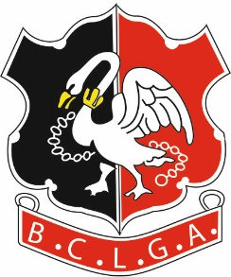 | Buckinghamshire County Ladies’ Golf Association
 | ROSE BOWL KNOCKOUT TROPHY 2022

Under the terms of the BCLGA Privacy Notice, BCLGA will no longer request and circulate ‘In Case of Emergency’ (ICE) information for knock-out competitions. It will be the player's own responsibility to exchange such information on the day of play with their opponent.

Under the terms of the BCLGA Privacy Notice, any contact details for individuals will be held for the duration of the competition only and then destroyed. However, we would like to build a communication database of BCLGA members, so that we may inform members directly of BCLGA events from time to time. If you are happy for your details to be added to the BCLGA communication database, please sign below:

I consent to my email address being added to the BCLGA communication database, so that I may be kept informed of BCLGA activities and events

Signed........................................

Print Name.................................

(Or parent/guardian’s details on behalf of junior player. Also note matches are not supervised by BCLGA so parent/guardian must take responsibility for arranging safeguarding of juniors)

Send the Entry Form to the Organiser. Payment to be made by a bank transfer as below.

If applicable, would you like to use your entry fee from the cancelled 2020 competition?
Please circle - Yes / No

Organiser:  Competition Organiser: Heather Pentney  Tel: 01494 763330 07768 500569  Email: kocomps@bclga.org.uk | Bank Details are:  Acc Name: BCLGA  Sort Code: 401712  Acc No: 51384856  Ref: Your Name Plus “Rose”  E.g. “HPentney Rose”  (to identify which competition the entry relates to)

