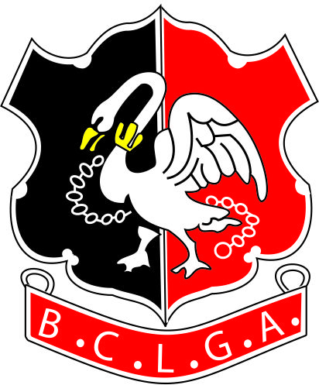 |  |  |  | Buckinghamshire County Ladies’ Golf Association
 |  |  |  | CHAMPION OF CHAMPIONS 2022

The competition is open to 2021 Club Scratch Champions of all clubs affiliated to the Buckinghamshire County Ladies Golf Association. Players must be members of clubs affiliated to the County Association and have a WHS Handicap Index. A player may only represent one club during the competition.

Please ensure your Club Champion is available throughout the tournament, which runs from
1 April 2022, with the final to be played no later than 20th October 2022, before putting her name forward. The Committee regrets that no replacement may be made.
Please return this Entry Form by 28th February 2022
Entry fee is £15

PLEASE PRINT CLEARLY

CLUB

Name

Telephone
Email
CDH no |  |  |  |  |  | Exact Handicap Index:
Under 18 | Yes/No |  | If yes, please give contact details of a parent/guardian:  Name  Tel  Email
Signed |  |  |  |  |  |  |  | (Ladies’ Captain)

Cont.

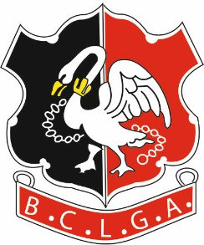 | Buckinghamshire County Ladies’ Golf Association
 | CHAMPION OF CHAMPIONS 2022

Under the terms of the BCLGA Privacy Notice, BCLGA will no longer request and circulate ‘In Case of Emergency’ (ICE) information for knock-out competitions. It will be the player's own responsibility to exchange such information on the day of play with their opponent.

Also note matches are not supervised by BCLGA so parent/guardian must take responsibility for arranging safeguarding of juniors)

Send the Entry Form to the Organiser. Payment to be made by bank transfer as below.

If applicable, would you like to use your Club’s entry fee from the cancelled 2020 competition?
Please circle - Yes / No

Organiser:  Competition Organiser: Heather Pentney  Tel: 01494 763330 07768 500569  Email: kocomps@bclga.org.uk | Bank Details are:  Acc Name: BCLGA  Sort Code: 401712  Acc No: 51384856  Ref: Your Name or Club Plus “Champ”  E.g. “HPentney Champ”  or “Denham Champ”  (to identify which competition the entry relates to)

