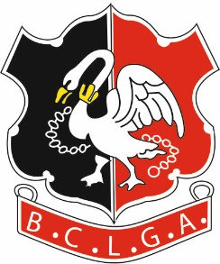 | Buckinghamshire County Ladies Golf Association
LADIES PAR 3 COMPETITION 2022
TERMS OF THE COMPETITION

1. | The Competition shall be played in according to the general BCLGA “Local Rules, Terms of the Competition and General Regulations”.
2. | The Competition shall be open to all members of the Buckinghamshire County Ladies Golf Association.  Players must be aged 18 years of age or over at 00:01am on 1st January 2022.
3. | The Competition will be played at Wycombe Heights Golf Club on the Par 3 course and will be an 18 hole competition played as a shot gun start.
4. | Players must have a WHS Handicap Index.
5. | The competition shall be played as a strokeplay competition (medal).  Playing Handicap is determined by calculating 50% of current Handicap Index, then rounding the result to the nearest whole number.
6. | There will be a scratch prize for the best gross score.  The handicap competition will be split into divisions based on equal number once entries are closed. Player will be advised of the handicap divisions before play.

Competition Organiser: | Jackie Maher
Tel: | 01753 642116
Mobile: | 07722 020186
Email: | compssec@bclga.org.uk

