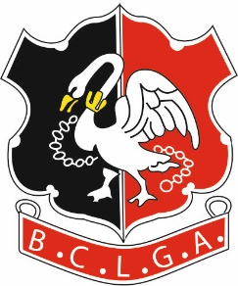 | Buckinghamshire County Ladies Golf Association
 | 43rd ANNUAL LUNCH
 | GERRARDS CROSS GOLF CLUB
WEDNESDAY 27th MARCH 2019
12.30 for 13.15

£

Closing Date for Applications - 18 March 2019
Your Delegate will receive a list of successful applicants;
if unsuccessful, your cheque will be returned.

Send the application form to:-
Helen Mines, Sobalym, Manor Road, Princes Risborough, Bucks HP27 9DJ

Payment:-
EITHER Include cheque for £35 payable to BCLGA
OR Pay by BACS quoting Ref “Co Lunch + your surname”
Account Name: BCLGA – Sort Code: 401712 – Acc No: 51384856

PLEASE PRINT CLEARLY
Name |  |  |  |  |  |  |  | Club

Telephone
Email
ICE Contact |  |  | Name |  |  |  |  |  | Tel

Starter Choice
Soup |  |  |  | Roulade

Main Course Choice
Chicken |  |  |  | Barramundi |  |  |  |  |  | Risotto (V)

Dessert Choice
Lemon Posset |  |  |  | Fresh Fruit Salad

OTHER NOTES
EG SPECIAL DIETARY NEEDS
or SEATING REQUESTS

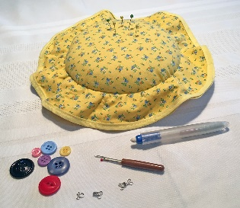 |  | 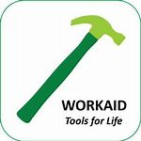 |  |  | Please bring along a small bag of your unwanted haberdashery items for Workaid to distribute. They will be put to good use. |  |  |  |  |  |  | 