

*ELLESMERE GOLF CLUB*

*VISITING SOCIETY* INFORMATION PACK 2025/2026

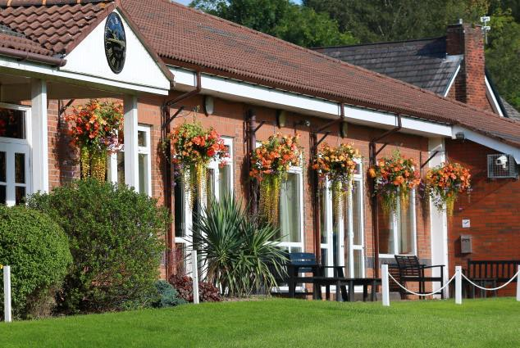

### ELLESMERE GOLF CLUB

Old Clough Lane, Worsley MANCHESTER

### M28 7HZ

Clubhouse: 0161 790 2122

Professional: 0161 790 8591

Brian Daniels (Hon Secretary) Jane Westley (Hon Asst Secretary) ([honsec@ellesmeregolfclub.co.uk](mailto:honsec@ellesmeregolfclub.co.uk)) Kathleen Donnegan (Stewardess) Anthony Millar (Professional) ([millargolf@hotmail.co.uk](mailto:millargolf@hotmail.co.uk)) Richard Moore (Caterer)

([r](mailto:mphcatering@yahoo.com)edievntandcontractcaterers@gmail.com)



**HOW TO BOOK YOUR GOLF DAY**

Simply complete the enclosed Booking Form and return it to the Hon Secretary together with a deposit of £100

Confirmation of your booking will normally be sent to you within two working days.

* **All players should be prepared to accept the state and play of the course on the day.**
* **We request all players observe the Club Rules and the Rules and Etiquette of Golf.**

PLEASE FEEL FREE TO VISIT OUR WEBSITE: [www.ellesmeregolfclub.co.uk](http://www.ellesmeregolfclub.co.uk/)

<><><>

Please return the completed Booking Form together with your deposit to: The Hon Secretary

Ellesmere Golf Club Old Clough Lane, Worsley

### MANCHESTER M28 7HZ

Or email to: [honsec@ellesmeregolfclub.co.uk](mailto:honsec@ellesmeregolfclub.co.uk)

Payment can be made by bank transfer to: Sort Code: 20-10-71 / Account No: 63589129

If you require further assistance, please contact us on the following number:

|  |  |  |
| --- | --- | --- |
| **Secretary:** | **Brian Daniels :** | **0161-790 2122 (option 1)** |
| **Asst Secretary:** | **Jane Westley :** | **0161-790 2122 (option 1)** |
| **Steward:** | **Kathleen Donegan :** | **0161-790-2122 (option 2)** |
| **Professional:** | **Anthony Millar :** | **0161-790 2122 (option 3)** |
| **Caterer:** | **Richard Moore :** | **0161-790-2122 (option 2)** |
|  | **Richard Moore :** | **07736576142** |



# ELLESMERE GOLF CLUB SOCIETY BOOKING FORM

## SOCIETY NAME: …………………………………….......................

Name of Organiser: …………………………………………………… Address: ……………………………………………………

……………………………………………………

…………………………………………………… Telephone Number:……………………Mobile:…………………………… Email Address: ……………………………………………………

----<><><>----

## Date Required: ………………….................... Deposit Paid: £………. (A non -refundable deposit of £100.00 is required)

**PACKAGES (see later for details) (Minimum of 12 players**

Golf Only:

Golf plus breakfast options

Golf plus 2 or 3 course meal

Golf plus breakfast & 2 or 3 course meal

Contact Preference: e-mail……………….. or mail………………………..



# DISCOUNTED SOCIETY PACKAGES

## (Minimum of 12 players)

## OPTIONS and PRICES

## (Please tick your choices)

## 18 Holes Golf Only (Monday to Friday) £40

## 18 Holes Golf Only (Sunday) £45

## 18 Holes Golf (Monday to Friday with catering) £35

## 18 Holes Golf (Sunday with catering) £40

## Coffee & Bacon Barm £7.50

## Full English Breakfast £10.50

## Soup & Sandwiches £10

## 2 Course Meal £15

## 3 Course Meal £21

## Minimum Number for all packages: 12 people

***Final numbers for catering to be confirmed to the Caterer 0161-790 2122 Option 2 / 07910 842954 or by email to*** [***honsec@ellesmeregolfclub.co.uk***](mailto:honsec@ellesmeregolfclub.co.uk)

***48 hours before the date of the event***



***GOLF SOCIETY MENU 2025/26***

***2 Course Meal Option***

|  |  |
| --- | --- |
| ***Starters:***  *Soup of the Day (with roll & butter) Chicken Liver Pâté*  *Melon with Berries* | ***Mains:***  *Homemade Meat & Potato Pie with crusty bread & red cabbage*  *Chicken Tikka Masala served with rice, chips & naan bread*  *Chilli con Carne served with rice, chips*  *Lasange, (Meat or Veg), chips, garlic bread* |
| ***Desserts:***  *Vanilla Cheescake*  *Apple Crumble & custard Chocolate & Orange Cake* |  |

----<><><>----

***3 Course Meal Option***

***Starters:*** *Creamy Garlic Mushrooms*

*Homemade Pork & Beef Meatballs in a spicy tomato & basil sauce*

*Prawn Cocktail*

***Mains:*** *Beef Bourguignon with Roasted Potatoes*

*Lamb Moussaka served with Greek Lemon & Garlic Potatoes & Feta Salad Roast Pork Dinner with Fresh Seasonal Vegetables*

***Desserts:*** *Sticky Toffee Loaf with Custard Tropical Fresh Fruit Salad Vanilla Cheesecake*

*English & French Cheese Selection with Grapes, Celery & Assorted Biscuits*

***The entire group (minimum 12 people), to select the same menu Vegetarian dishes available with 48 hours prior notice***

For more information, please contact the Caterer on 0161-790-2122 Option 2 or 07736576142



# INFORMATION FOR VISITING SOCIETIES

**SOCIETY DAYS:** Bookings are normally accepted every day of the week

except Wednesday and Saturday, although only 18 holes of golf are allowed on Thursday, Friday and Sunday.

Play must commence from the 1st tee which is available from 9.30am and 1.30pm, except on Friday and Sunday when the earliest start time is 12 noon. All tee times will be reserved and must be strictly adhered to. (27 holes - 9.30am & 1.30pm tee times).

**ETIQUETTE:** All players must abide by the Rules of the Club and show

good etiquette both on and off the course.

**PACE OF PLAY:** All players must keep up with pace of play and where possible should play ‘ready golf’.

## DRESS CODE: Correct golfing attire must be worn at all

**TIMES.**

Smart jeans and trainers are allowed in the Clubhouse only. Trainers, collarless tee shirts and sweatshirts with large logos are not acceptable on the course or putting green. Golf shirts and sports socks with golf shoes to be worn. Golf hats must be worn in the appropriate manner. Tailored knee length shorts are allowed but must be worn with appropriate sports socks*.*

***(Changing in the Car Park, other than shoes, is prohibited)***

Smart Casual Dress is required in the Clubhouse at all times, no flip flops or beachwear.

**BAR:** The Bar is open from 12 noon with a selection of Marston’s beers, cask ales, fine scotches and a detailed wine menu.

You are welcome to use our snooker table until 8pm.

