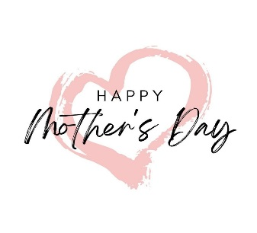
The Grimsby Golf Club – Mother’s Day Lunch
Sunday 15th March 2026
Served between 12 -4pm
To Start

Homemade Cream of Chicken Soup (GFA)
Served with Croutons and Warm Roll

Classic Prawn Cocktail (GFA)
Served with Salad, Marie Rose Sauce and Wholemeal Bread

Chicken Liver Pate (GFA)
Served with Salad, Chutney and French Toast

Creamy Garlic Mushrooms (v/GF)
Served with Salad and Garlic Slice

To Feast

Spring Roast Chicken Breast (GFA)
Served with Mashed, Roasted Potatoes, Sage Stuffing, Pig in Blanket, Traditional Gravy and Seasonal Vegetables

Beef Stroganoff (GFA)
Served with Mashed, Roasted Potatoes and Seasonal Vegetables

Moussaka (GFA)
Served with Fresh Greek Salad

Pan Fried Seabass (GF)
Served with Spinach, Lemon Butter Sauce and Seasonal Vegetables

Ratatouille and Mozzarella Stack (v/ve/GFA)
Served with Roasted Tomato Sauce

To Finish

Homemade Apple and Mixed Berry Crumble (v/ve)
Served with Custard
Warm Cherry Pie (v)
Served with Cherry and Amaretti Ice Cream

Tangy Lemon Tart (v/GFA)
Served with Mixed Berries and Forest Fruit Coulis
Chocolate and Hazelnut Slice
Served with Chocolate Sauce and Vanilla Ice Cream

Chefs Cheese Selection (v/GFA)
Selection of Cheese with Crackers, Celery, Grapes and Chutney

Freshly Brewed Tea or Coffee
Served with After Dinner Mint

Two Courses – £27.95 per person
Three Courses - £33.95 per person

Name | Starter | Main | Dessert

PRE ORDERS NEED BY SUNDAY 8th MARCH

£10pp deposit required on booking
Catering Team – 01472 342630 – catering@grimsbygolfclub.co.uk

(v- Vegetarian /ve – can be made suitable for vegan on request /GFA – can be made Gluten Free on request)

