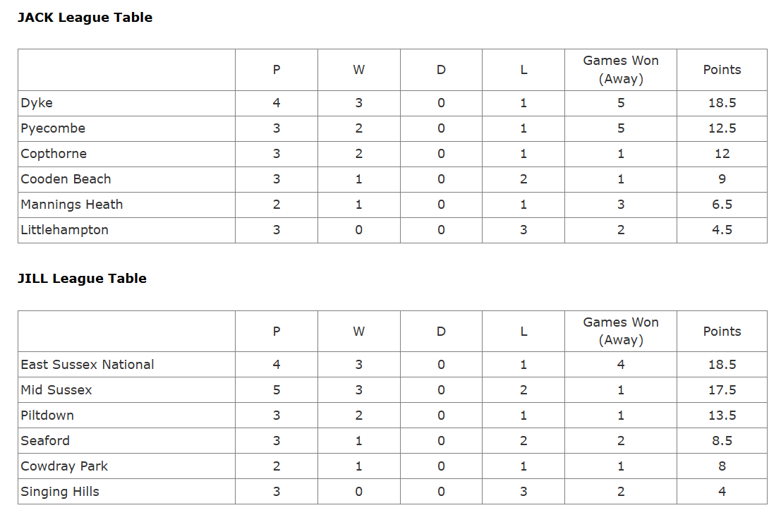
PYECOMBE PITCHER TABLES 2025

