
Winners (Team Nearest the bar)
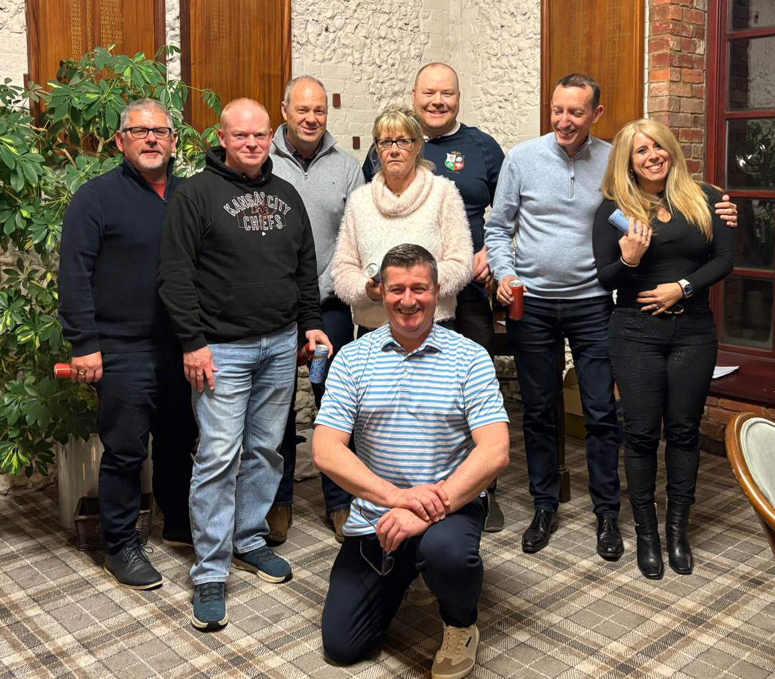
Runners Up (Team Chipping Hell)

